1971
Permanganate ion, MnO₄⁻, oxidizes sulfite ions to sulfate ion. The manganese product depends upon the pH of the reaction mixture. The mole ratio of oxidizing to reducing agent is two to five at pH 1, and is two to one at pH 13. For each of these cases, write a balanced equation for the reaction, and indicate the oxidation state of the manganese in the product containing manganese.
Answer:
2 MnO₄⁻ + 5 SO₃²⁻ + 6 H⁺ → 2 Mn²⁺ + 3 H₂O + 5 SO₄²⁻ (oxidation state Mn = +2)
2 MnO₄⁻ + SO₃²⁻ + 2 OH⁻ → 2 MnO₄²⁻ + H₂O + SO₄²⁻ (oxidation state Mn = +6)

1981 B
A 1.2516 gram sample of a mixture of CaCO₃ and Na₂SO₄ was analyzed by dissolving the sample and completely precipitating the Ca²⁺ as CaC₂O₄. The CaC₂O₄ was dissolved in sulfuric acid and the resulting H₂C₂O₄ was titrated with a standard KMnO₄ solution.
(a) Write the balanced equation for the titration reaction, shown unbalanced below.
MnO₄⁻ + H₂C₂O₄ + H⁺ → Mn²⁺ + CO₂ + H₂O
Indicate which substance is the oxidizing agent and which substance is the reducing agent.
(b) The titration of the H₂C₂O₄ obtained required 35.62 milliliters of 0.1092 molar MnO₄⁻ solution. Calculate the number of moles of H₂C₂O₄ that reacted with the MnO₄⁻
(c) Calculate the number of moles of CaCO₃ in the original sample.
(d) Calculate the percentage by weight of CaCO₃ in the original sample.
Answer:
(a) 2 MnO₄⁻ + 5 H₂C₂O₄ + 6 H⁺ → 2 Mn²⁺ + 10 CO₂ + 8 H₂O
oxidizing agent: MnO₄⁻ , reducing agent: H₂C₂O₄
(b)
(c) moles of H₂C₂O₄ = moles CaCO₃, therefore, 9.72×10⁻³ mol H₂C₂O₄ = 9.72×10⁻³ mol CaCO₃
(d) 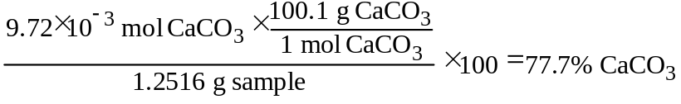

1986 D
(a) Describe what you would see if you added
1. a piece of zinc metal to a test tube that contains 6 molar hydrochloric acid.
2. a piece of copper metal to another test tube that contains 6 molar hydrochloric acid.
(b) Write balanced equations for any reactions that occur.
(c) Explain how you could use the table of standard reduction potentials [attached] to predict the observed results.
(d) In a separate experiment, concentrated nitric acid is added to a test tube containing a piece of copper metal.
1. Describe what you would see.
2. Explain any differences between the results obtained in this experiment and those obtained with copper metal in part (a).
Answer:
(a) 1. Bubbling or dissolving of Zn
2. No reaction
(b) Zn + 2 H⁺ → Zn²⁺ + H₂ or Zn + 2 HCl → ZnCl₂ + H₂
(c) The table shows that Zn is a better reducing agent than H₂, so Zn can reduce H⁺ in HCl to H₂. Cu is a weaker reducing agent than H₂, so no reaction occurs when Cu is added to HCl.
(d) 1. A reaction occurs in which a brown gas is given off OR the solution turns blue or green OR copper dissolves.
2. Nitric acid is an oxidizing acid and hydrochloric acid is not. OR Nitric acid is a better oxidizing agent than Cu²⁺ is. OR equivalent explanation.

1994 D (Required)
Discuss the following phenomena in terms of the chemical and physical properties of the substances involved and general principles of chemical and physical change.
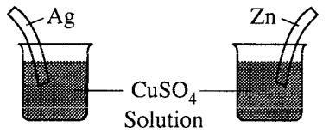
(c) What will be observed on the surfaces of zinc and silver strips shortly after they are placed in separate solutions of CuSO₄, as shown on the right? Account for these observations.
Answer:
(c) No reaction in the Ag | Cu²⁺ beaker because Ag⁺ is easier to reduce than Cu²⁺.
The zinc will go into solution as Zn²⁺ while the Cu²⁺ will reduce to Cu, forming on the surface of the zinc.
Zn(s) + Cu²⁺ → Zn²⁺ + Cu(s) E°_{cell} = + 1.10 v

1998 D
Answer each of the following using appropriate chemical principles.
(d) Identify a chemical species that is
(i) capable of oxidizing Cl⁻(aq) under standard conditions
(ii) capable of reducing Cl₂(aq) under standard conditions.
In each case, justify your choice.
Answer
(d)i 2 Cl⁻ - 2 e⁻ → Cl₂, E° = -1.36v Any species that has a reduction potential greater than +1.36v, such as Au³⁺ or Co³⁺ or F₂, will oxidize the chloride ion.
ii Cl₂ + 2 e⁻ → 2 Cl⁻, E° = +1.36v Any species that has an oxidation potential greater than -1.36v, such as Li, Cs, K, will cause chlorine to be reduced.

